

**Production Management Methods**

**Report**

Ceramic mug – production by 5Ps

Michał Ogłuszka 257104

Maciej Gara 257093

Stanisław Kotowicz 257100

Sofia Neves 905422

Ana Carvalho 905431

# Table of contents

Table of contents 1

1. Introduction 2

2. Product description 2

3. Process 3

3.1 Raw Materials & Preparation 4

3.2 Shaping & Handle Attachment 4

3.3 Drying 5

3.4 Bisque Firing 5

3.5 Glazing & Decoration 5

3.6 Glaze Firing 5

3.7 Quality Control 5

3.8 Packaging & Shipping 6

4. Plant 6

4.1 Production environment 6

4.2 Plant Facilities 7

4.3 Factory layout 9

4.4 Safety measures in a plant 10

5. Program 12

5.1. Production scheduling 12

5.2. Resource allocation 12

5.3. Performing monitoring 13

6. People 13

6.1 Workforce Structure and Responsibilities 13

6.2 Skills and Competency Requirements 14

6.3 Team Integration and Collaboration 14

7. Summary 15

# Introduction

The aim of this report is to describe the production of ceramic mugs by using the 5Ps framework - Product, Process, Plant, Programs, and People. Conducting this method allowed us to deeply understand manufacturing processes and applying production management principles. We chose the mug because it is a simple, everyday object that people form personal connections with through daily rituals like coffee and tea.

# Product description

Company serves variety of colors and mug sizes. Size depends on mold parameters, color on different paints.

Mug dimensions:

1. Capacity: 300–350 ml
2. Height: 90–100 mm
3. Outer Diameter: 80–85 mm
4. Wall Thickness: 4–6 mm
5. Handle Width : 30–35 mm
6. Handle Thickness: 8–12 mm
7. Total Weight: 350–450 g
8. Base Diameter: 60–65 mm



Exemplary products

# Process

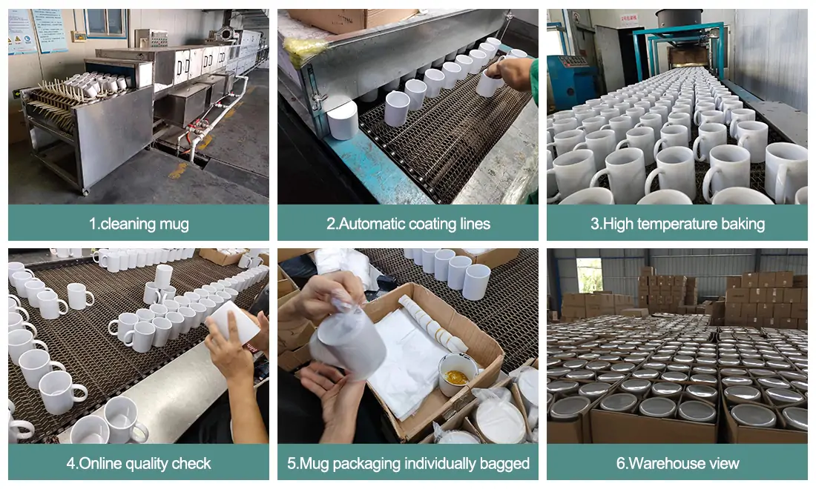

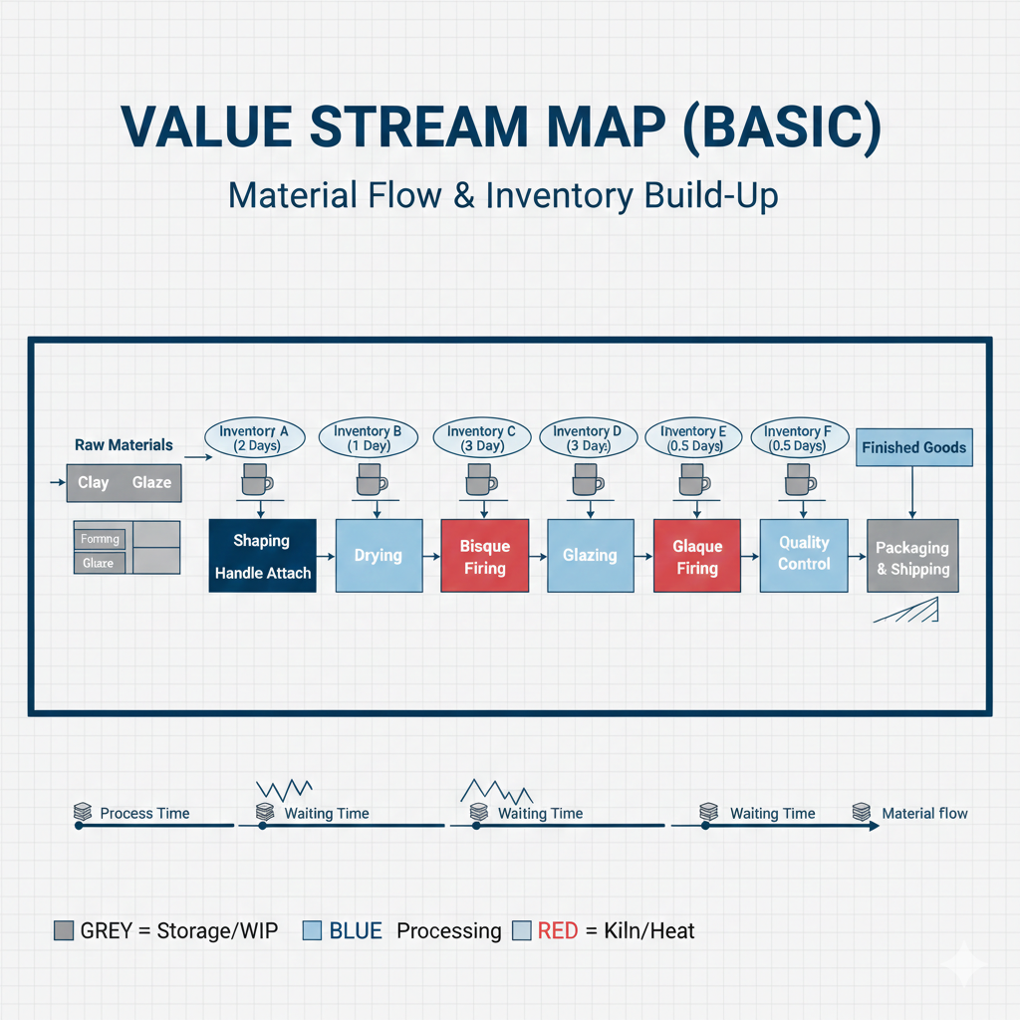

## 3.1 Raw Materials & Preparation

The production cycle begins with the sourcing and refinement of high-quality clay bodies and glaze components, which are essential for structural integrity and aesthetic finish. Once the raw materials arrive, the clay must undergo a process called wedging, which is a manual or mechanical kneading technique used to eliminate trapped air bubbles and ensure the moisture content is uniform throughout the mass. This preparation is a critical safety step because any hiden air pockets can expand rapidly in the heat of the kiln, causing the piece to crack or explode during the first firing.

## 3.2 Shaping & Handle Attachment

The mug body is formed using one of three primary methods: wheel throwing for artisanal pieces, slip casting for high-volume production, or hand-building for unique textures. Once the cylinder is shaped and has dried to a leather-hard consistency—where it is firm but still workable—the potter trims the base to create a stable foot. During this same stage, handles are extruded or hand-pulled and attached to the body using a technique called slipping and scoring, which creates a strong mechanical bond between the two pieces of clay.

## 3.3 Drying

Before a mug can ever be fired, it must undergo a slow and controlled drying period to remove all physical water trapped within the clay particles. This stage is highly sensitive to environmental factors like humidity and temperature; if the mug dries too quickly, it can warp or develop hairline fractures known as drying cracks. The process is complete only when the piece reaches the bone-dry stage, at which point the clay is extremely fragile but ready to withstand the intense thermal changes of the first kiln session.

## 3.4 Bisque Firing

The bone-dry mug is loaded into the kiln for the bisque fire, where it is slowly heated to temperatures between $900^\circ\text{C}$ and $1060^\circ\text{C}$. This initial firing causes a permanent chemical change in the clay, transforming it from a fragile mud into a durable, stone-like ceramic material that will no longer dissolve in water. While the piece is now quite hard, it remains intentionally porous, which allows it to act like a sponge and absorb the moisture from the liquid glaze that will be applied in the next phase of production.

## 3.5 Glazing & Decoration

Glazing is the process of applying a liquid suspension of minerals, oxides, and silica to the surface of the bisqueware through dipping, spraying, or painting techniques. This coating is not merely decorative; it is engineered to react with heat to create a glass-like surface that makes the mug non-porous and easy to clean. During this stage, artists may also apply underglazes or wax resists to create intricate patterns, ensuring that the final product is both a functional drinking vessel and a piece of visual art.

## 3.6 Glaze Firing

The final firing is the most intense part of the process, as the kiln is pushed to much higher temperatures, often exceeding $1200^\circ\text{C}$. At these levels, the clay undergoes vitrification, a process where the particles fuse together so tightly that the material becomes completely waterproof even without glaze. Simultaneously, the mineral coating melts and flows over the surface, cooling into a smooth, glassy finish that seals the mug and makes it food-safe for daily use.

## 3.7 Quality Control

After the kiln has cooled slowly to prevent thermal shock, each mug is subjected to a rigorous quality control inspection to identify any structural or cosmetic flaws. Inspectors look for common defects such as crazing, which are tiny cracks in the glaze, or "pinholes" caused by gases escaping during the fire. Every piece is checked for balance and handle strength to ensure that only the highest quality items move forward to the consumer, maintaining the standards of the studio or factory.

## 3.8 Packaging & Shipping

The final stage involves the transition from the workshop to the marketplace, where the finished goods are prepared for safe transport. Because ceramics are inherently brittle, they are wrapped in protective cushioning and placed in specialized boxes to survive the rigors of shipping and handling. This logistical phase ensures that the product—which has spent days or weeks in production—arrives intact at its final destination, ready to be used by the customer.

# Plant

Our selected item is typically produced in a clean, organized manufacturing plant which combines raw material processing with other significant processes such as shaping, drying, firing, glazing, decoration and, last but not least - packaging. On the grounds of high temperature requirements and careful handling the factory should seek out to provide safe working conditions by introducing Lean Management techniques for instance Kanban cards, thus efficiently increasing the flow between production steps.

## 4.1 Production environment

The production environment is designed to support:

* High temperature operations
* Dust control and ventilation
* Safe material handling
* Consistent quality conditions
* Separate clean zones

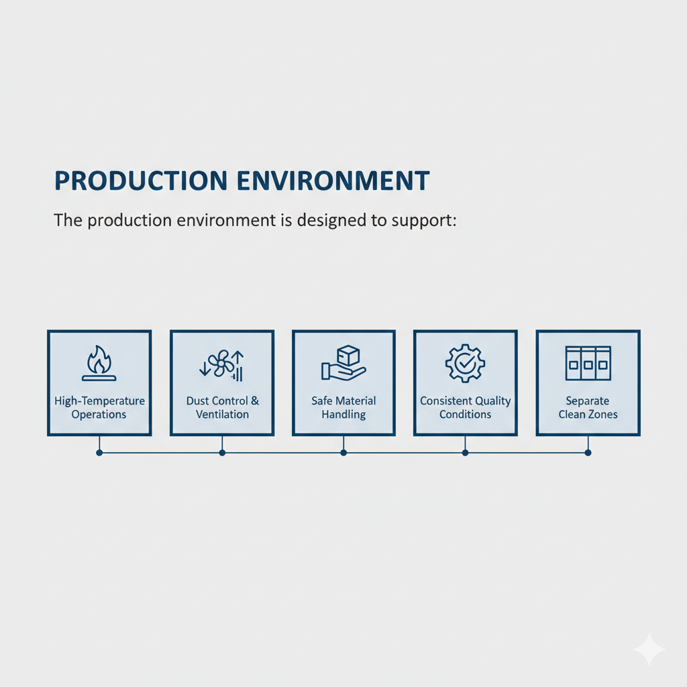

## 4.2 Plant Facilities

For a typical ceramic mug production facility includes:

1. **Raw Material Storage & Preparation**

* Storage for clay, additives, water and glaze materials
* Mixing and preparation area for producing uniform clay “slip” or plastic clay

1. **Shaping / Forming Area**

* Mug forming using:
  + **Slip casting** (liquid clay poured into molds)
  + **Jiggering / pressing** (mechanical shaping)
* Handle forming station (molded separately or attached later)

1. **Drying Area**

* Controlled drying rooms or conveyor dryers
* Prevents warping and cracks before firing

1. **Firing Area**

* **Bisque kiln** (first firing to harden the mug body)
* High-temperature kilns require:
  + heat shielding
  + safety barriers
  + restricted access zones

1. **Glazing Area**

* Automated or manual glazing lines (spray / dipping)
* Often separated due to chemical handling and cleanliness requirements

1. **Final Firing (Glaze Firing)**

* Second kiln firing to melt glaze and strengthen the surface
* Creates the final finished appearance

1. **Decoration / Printing Area (Optional)**

* Logo printing or pattern transfer (screen printing, decals, digital printing)

1. **Quality Control & Inspection**

* Checks for cracks, glaze defects, incorrect dimensions, and visual flaws

1. **Packaging & Shipping**

* Protective packaging (foam inserts, boxes)
* Palletizing and storage for transport

Exemplary machines required for ceramic mug production:

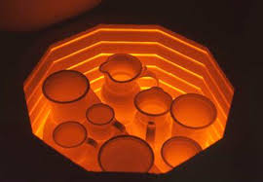

*Bisque klin*

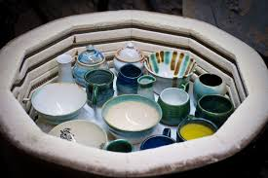

*Glaze klin*

## 4.3 Factory layout

The factory layout is organized following a linear (straight line) sequence in order to minimize material handling and ensure safety in a high-heat environment.

At the start, Raw Material Storage is placed immediately next to the Forming Area to shorten the distance heavy clay and water must travel. Furthermore, this would reduce significantly the physical strain on workers. In the Forming Area there are mug forming area (slip casting) and handle forming station. Then, the Drying zone (indicated in white in the picture below) is positioned as a necessary transition point before the mugs enter the Firing Area. It is crucial because it ensures that all moisture is removed in a controlled environment, preventing a potential failure when the mugs enter the kilns.

The Firing Area is located at the center of the factory. It is intentionally encased in a restricted-access hot zone (indicated visibly in red) to isolate the intense heat and potential hazards from the rest of the staff. Moreover, this central positioning allows for the most efficient installation of high-capacity ventilation systems and heat shielding, thus minimising the cost of installation. Once the mugs have been fired, they move into the Glazing and Decoration areas. These are kept downstream and physically separated from the raw material section to maintain a clean environment. Unfortunately, even a small amount of clay dust in the air during this stage can cause permanent surface defects on the finished glaze.

The final section of the plant houses Quality Control and Packaging & Shipping. Quality Control acts as the final step, situated right before the packaging line to ensure that no defective items are wasted on expensive protective wrapping or shipping costs (maintain quality and high expectations of customers). The Packaging area is designed with wide access points and ramps to accommodate the heavy machinery, such as forklifts and pallet jacks, required to transport finished goods to the loading docks.

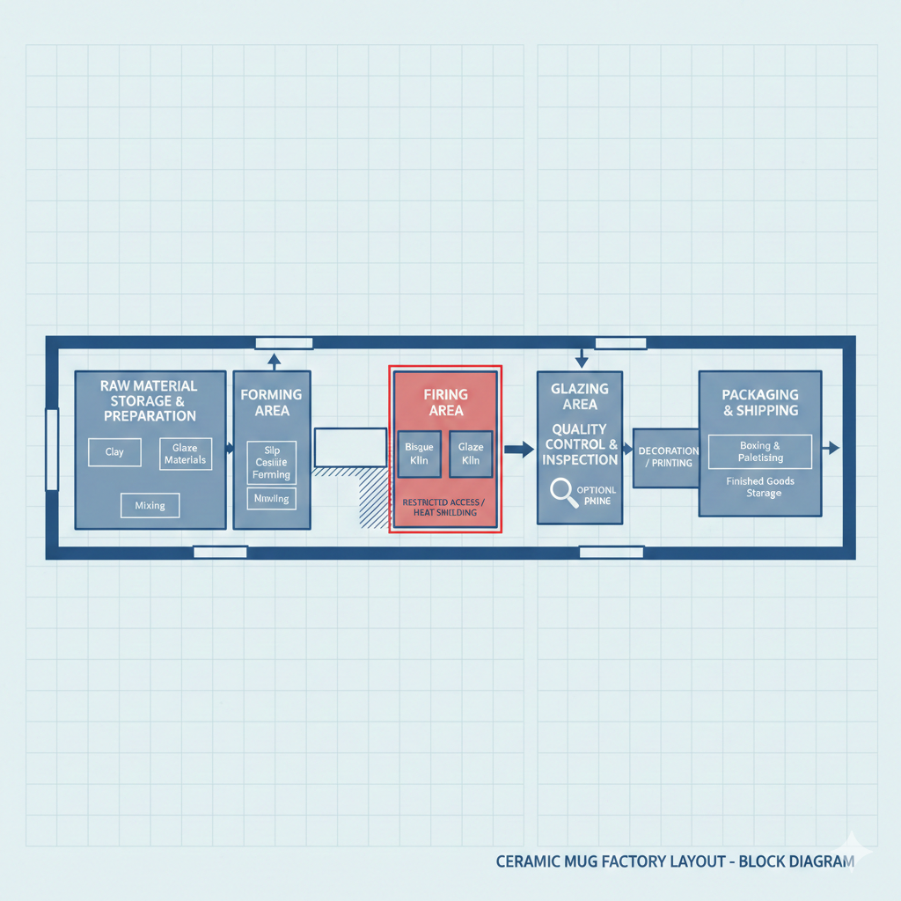*Exemplary factory layout diagram (block layout)*

## 4.4 Safety measures in a plant

Safety within a ceramic plant relies on a combination of visual communication, physical engineering and strict procedural controls to manage the unique risks of dust and extreme heat.

One of the most effective tools for real-time safety management is the use of specialized Kanban cards. Such a technique was mentioned during the presentation about lean management. Unlike inventory Kanbans, safety-focused cards serve as high-visibility signals for maintenance and hazard awareness. For example, Equipment Status cards are attached to machinery like slip mixers or jiggering arms to indicate when a machine is "Locked Out" for repair. This can prevent accidental activation. Similarly, Hazard Alert cards are permanently stationed at the boundaries of the kiln area to mandate the use of specific PPE, such as heat-resistant gloves and face shields, before a worker enters the hot zone.

Dust control represents the most significant long-term health priority in terms of the factory system. It is due to the risk of silicosis from dried clay particles. That is exactly why the plant needs to utilize ventilation systems at every station where dry clay is handled or mugs are sanded. To ensure these systems remain effective, the factory employs a "Signal and Check" technique where green Dust Control Kanbans are used to track filter life and airflow sensor calibrations (as shown in the picture below). If a filter's efficiency drops below a set threshold, the card is moved to a "Service Required" board, triggering immediate maintenance.

Finally, the physical layout is reinforced by floor markings and color-coded zoning. High-temperature areas near the kilns are marked with red lines to indicate restricted access, while blue-coded zones signify areas where standard safety gear, such as steel-toed boots and safety glasses, must be worn at all times. These visual cues, combined with the automated signaling of the Kanban system, create a self-correcting environment where safety requirements are obvious even without direct supervision.

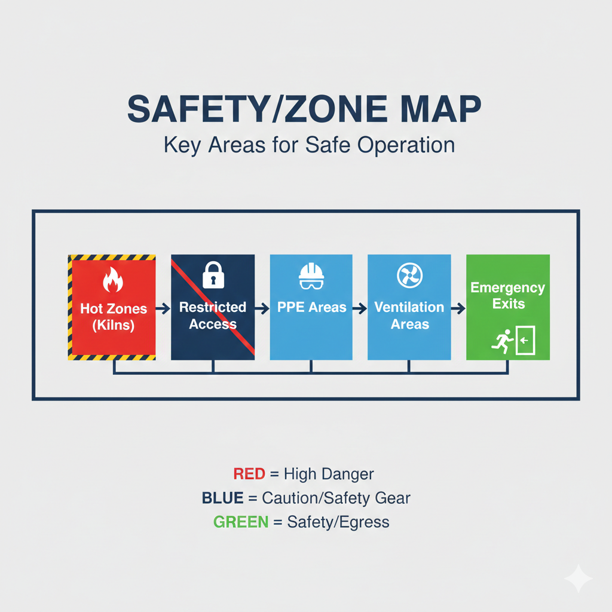*Safety zone/map*

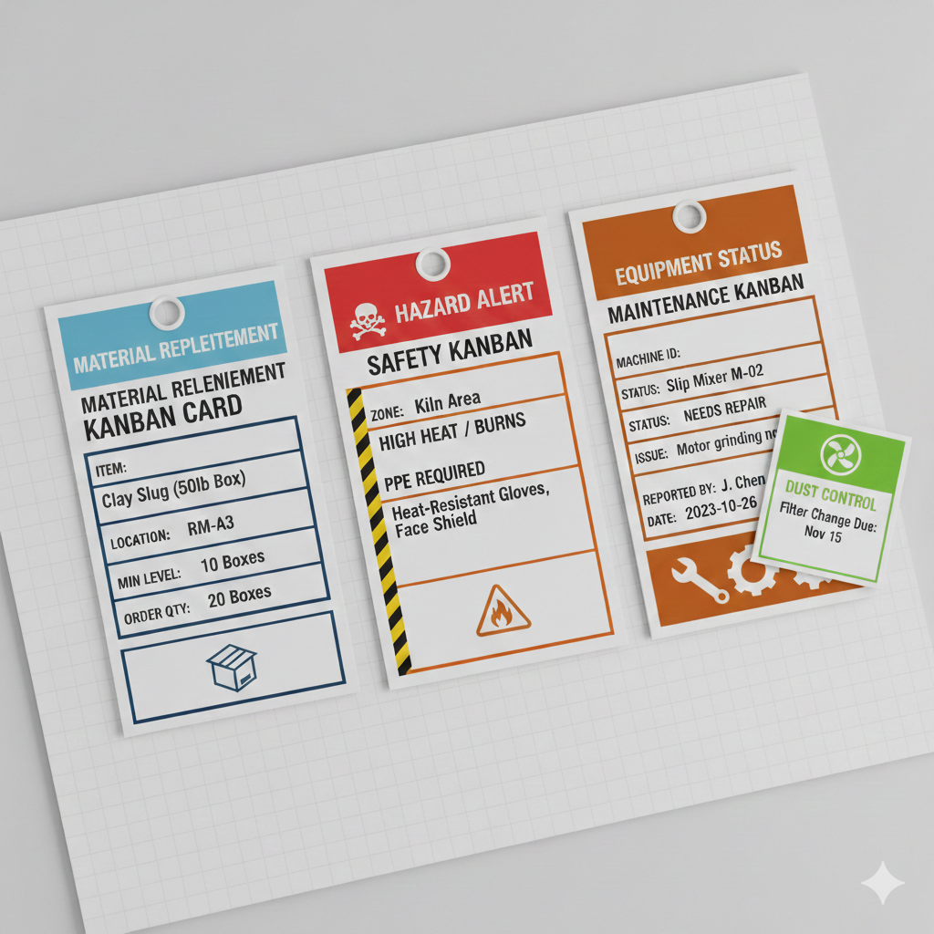*Exemplary Kanban cards*

# 5. Program

## 5.1. Production scheduling

Due to long drying and firing times, it is suitable that production is organized in batch cycles. The process sequence, as described in the last point, points that the firing process represents a capacity bottleneck, so kiln operations must be planned carefully. To maximize efficiency and reduce changeover times and energy consumption, mugs are grouped by size and glaze type. The firing and drying processes are synchronized to prevent material accumulation and idle time.

## 5.2. Resource allocation

Raw materials, such as clay and glaze, are managed using a controlled pull system, this means that the process of making a ceramic mug is only initiated when there is a demand for it, avoiding excessive inventory and material degradation.

Depending on the material, there are certain conditions that must be taken into consideration. For example, the assurance that clay is stored within the conditions that maintain its moisture conditions, the glaze is allocated to color and finish requirements to reduce cleaning time in the glazing station.

Kanban cards are used to signal replenishment of clay and glaze materials at each workstation. This technic ensures uninterrupted flow between process stages.

Regarding the machine allocation, forming machines, drying machines and glazing lines are allocated based on kiln availability, preventing bottlenecks. Preventive maintenance is scheduled during low-demand periods to reduce unplanned downtime and protect equipment lifespan.

## 5.3 Performance Monitoring & KPI Management

In the production of ceramic mugs, we prioritize **prevention over correction** due to the irreversible nature of ceramic firing. To maintain this, we utilize a robust set of Key Performance Indicators (KPIs) that allow for real-time adjustments and long-term strategic improvements.

Core KPI Targets

To ensure the plant operates at peak efficiency, the following target values have been established:

|  |  |  |
| --- | --- | --- |
| KPI Metric | Target Value | Definition |
| First Pass Yield (FPY) | ≥ 92% | Mugs that pass final inspection without needing rework or being scrapped. |
| Cycle Time (Shaping) | 45 Seconds | Average time to form one mug body (automated slip casting/jiggering). |
| Kiln Utilization | ≥ 95% | Percentage of kiln volume used per firing cycle to optimize energy costs. |
| Scrap Rate | ≤ 5% | Percentage of material lost due to breakage or irreversible defects. |
| OEE (Overall Equipment Effectiveness) | ≥ 70% | Combined measure of machine availability, performance, and quality. |

## 5.4 Monitoring & Accountability

KPIs are not just recorded; they are actively monitored at different levels of the organization:

* Real-Time (Hourly): Process Controllers monitor automated dashboards on the factory floor. If the cycle time exceeds 50 seconds or the shaping defect rate spikes, they perform immediate "on-the-spot" troubleshooting.
* Daily: Shift Supervisors review the Daily Shift Report. They compare the actual output against the Program schedule. These results are discussed during 5-minute meetings at the end of each shift.
* Weekly: The Quality Assurance Manager and Plant Manager conduct a deep-dive analysis into trend data. This is where issues, like a slow drift in kiln temperature accuracy, are identified.

## 5.5 Data-Driven Decision Making

The primary purpose of these KPIs is to trigger Continuous Improvement (Kaizen).

1. Corrective Actions: If the Yield Rate drops below 90%, it triggers an immediate investigation into the "Process" (e.g., checking clay moisture levels or glaze viscosity).
2. Preventive Actions: If Machine Downtime trends upward, the Safety and Environmental Engineers use this data to reschedule preventive maintenance, moving it forward to avoid a total system failure.
3. Strategic Adjustments (PDCA): Using the Plan-Do-Check-Act cycle, if a specific glaze consistently results in "crazing" (visual defects), the data is used to justify a chemical reformulation of the glaze or a modification of the cooling curve in the Glaze Kiln.

# 6. People

The final pillar of the 5P framework focuses on the human capital required to operate and manage the production system. In this highly automated facility, the role of "People" transitions from manual labor to technical oversight, process synchronization, and quality auditing.

## 6.1 Workforce Structure and Responsibilities

To ensure the effective implementation of the production program, the team is organized into specialized roles that manage the automated "Plant" and "Process":

* Process Controllers: Responsible for the real-time monitoring of the automated forming and shaping lines from centralized control interfaces.
* Thermal Systems Technicians: Tasked with managing the digital temperature curves of the bisque and glaze kilns located within the restricted-access "hot zone".
* Quality Assurance Auditors: Instead of manual inspection, these specialists oversee automated optical sensors and perform high-level audits to ensure every mug meets customer specifications.
* Safety and Environmental Engineers: Focused on maintaining the facility’s critical infrastructure, such as high-capacity ventilation for dust control and the integrity of heat shielding.
* Logistics and Flow Coordinators: They manage the "Program" pillar, overseeing resource allocation and the automated transfer of finished goods to the packaging and shipping department.

## 6.2 Skills and Competency Requirements

Operating a non-manual, lean-focused plant requires a workforce with advanced technical competencies:

* Systems Troubleshooting: Personnel must be skilled in diagnosing mechanical and electronic issues to prevent production bottlenecks.
* Lean Management Literacy: Every employee is trained to interact with the Kanban system, using visual signals to track machine status and trigger maintenance actions.
* Industrial Safety Awareness: Staff are required to strictly comply with to the color-coded zoning and PPE protocols defined by the factory’s safety map.

## 6.3 Team Integration and Collaboration

Following the project's international collaboration requirements, the team is encouraged to incorporate global expertise to solve technical challenges. By integrating the "People" with automated systems, the factory maintains high efficiency, consistent quality, and a competitive edge in the ceramic market.

7. Quantitive data about production

## 7.1 Production capacity benchmarks

The capacity of a ceramic factory is primarily determined by its kiln volume and shaping technology.

* **Average Output:**
  + Per Shift (8h**):** 1,500 – 2,500 units. A standard jiggering machine can produce 4–6 mugs per minute, but the "Handle Attachment" station often limits this to ~300 per hour per worker.
  + Per Day (3 shifts): 4,500 – 7,500 units.
  + Per Week (5 days): 22,500 – 37,500 units.
* **Batch & Kiln Size:**
  + **Kiln Capacity:** Standard industrial shuttle kilns for mugs often range from **4 $m^{3}$ to 10 $m^{3}$**
  + **Setting Density:** Typically, **300 kg/ $m^{3}$**. In a 4 $m^{3}$ kiln, you can fire approximately **800 to 1,200 mugs** per cycle depending on the "kiln furniture" (racks/shelves) used.

## 7.2 Quality metrics (Yield and defects)

Ceramics have one of the highest "Scrap Rates" in manufacturing due to the chemical and thermal volatility of the process.

* **First-Pass Yield (FPY):** A world-class target is **90–95%**, though many enterprises operate at **80–85%**.
* **Common Defect Distribution:**
  + Glaze Issues (22%)**:** Pinholes and "crawling" caused by dust or surface oils.
  + Structural Cracks (18%)**:** "Drying cracks" (pre-firing) or "dunting" (cooling too fast in the kiln).
  + Decoration Errors (12%)**:** Logo fading or misalignment during the decal/printing stage.

Common defect distribuition was yielded in the report titled: *Application of Six Sigma DMAIC Methodology in a Ceramic Tableware Manufacturing Unit* in which a Pareto analysis was conducted for a ceramic factory producing 1500 mugs daily.

## 7.3 Lean implementation: Case Study

Industry data from ceramic clusters shows that shifting from "Batch-and-Queue" (traditional, inefficient manufacturing method where large, identical, or similar items (batches) are processed together in steps) to "One-Piece-Flow" (products move through production processes one unit at a time) yields significant results as well as introducing kaizens such as machine operators multi-skill training:

* Lead Time Reduction: Implementations of Lean and Kanban have shown a reduction in total production time from 24 days down to 16 days (a 32% improvement).
* WIP (Work in Progress) Reduction**:** By using Kanban cards between the "Forming" and "Drying" zones, factories have successfully reduced inventory build-up by **36%**, freeing up significant floor space.
* Space creation for further use
* Reduction in manpower by 6.85%
* Defects reduction by 40.51%
* Cost saving of US $ 0.61 million in one financial year

Source of a case study: "Lean Manufacturing Implementation in Ceramic Industry: Case Study". It presents a similar process to the production of a ceramic mug.

## 7.4 Technical & Energy KPIs

* **Energy Intensity:** Energy accounts for **25%–30%** of total production costs.
* **Specific Energy Consumption:** Approximately **1.5 to 3.5 kWh per kg** of fired product. Modern kilns with heat recovery systems can reduce this by utilizing exhaust heat for the Drying Area.
* **Overall Equipment Effectiveness (OEE):** A typical ceramic plant operates at 60% OEE, with a target of 85% for world-class automated facilities.

## 7.5 References for quantitive data research

Ceramic Manufacturing Industry - Best Available Techniques Reference Document (BREF) - European Commission

Case study: "Lean Manufacturing Implementation in Ceramic Industry"

Defects: *Application of Six Sigma DMAIC Methodology in a Ceramic Tableware Manufacturing Unit*

OEE and First-Pass-Yield: *World-Class Manufacturing (WCM) Benchmarks for Ceramic Industry*

# 8. Summary

This report breaks down the journey of a ceramic mug from raw clay to a finished kitchen staple using the 5Ps framework. We focused on how a simple, everyday object—the 300ml mug—requires a sophisticated balance of precision and safety. The Process moves through shaping and drying into a carefully planned Plant layout. Because kilns reach intense temperatures and clay dust poses health risks, the factory is designed with a "hot zone" at its center and a linear flow that keeps the glazing area pristine. To keep things running smoothly, we integrated Lean tools like Kanban cards, which act as visual signals for everything from restocking clay to flagging equipment that needs a safety check.

The "brain" of the operation lies in the Programs and People. Since firing ceramic is irreversible, the production schedule is built around the kilns to avoid bottlenecks, using a "pull system" to ensure we only make what is needed. This shift moves the workforce away from heavy manual labor and into technical roles, where People act as process controllers and quality auditors. By focusing on prevention rather than just fixing mistakes after they happen, the facility creates a high-quality product in an environment that is both safe for the workers and efficient for the business.

# 8. Quantitative Data Summary

This section summarizes the key quantitative parameters and targets defined throughout the production process for ceramic mugs.

## 8.1 Product Specifications

The following table presents the dimensional specifications for standard ceramic mugs produced in the facility:

|  |  |
| --- | --- |
| **Parameter** | **Value** |
| Capacity | 300–350 ml |
| Height | 90–100 mm |
| Outer Diameter | 80–85 mm |
| Wall Thickness | 4–6 mm |
| Handle Width | 30–35 mm |
| Handle Thickness | 8–12 mm |
| Total Weight | 350–450 g |
| Base Diameter | 60–65 mm |

## 8.2 Process Parameters

Critical temperature and time parameters for each production stage:

|  |  |
| --- | --- |
| **Process Parameter** | **Value** |
| Bisque Firing Temperature | 900–1060°C |
| Glaze Firing Temperature | >1200°C |
| Bisque Firing Duration | 8–12 hours (incl. heating/cooling) |
| Glaze Firing Duration | 10–14 hours (incl. heating/cooling) |
| Controlled Drying Time | 24–48 hours |
| Clay Moisture Content at Forming | 20–25% |
| Bone-Dry Moisture Content | <1% |

## 8.3 Key Performance Indicators (KPIs)

Target values for production efficiency and quality control:

|  |  |  |
| --- | --- | --- |
| **KPI Metric** | **Target** | **Description** |
| First Pass Yield (FPY) | ≥92% | Mugs passing final inspection without rework |
| Cycle Time (Shaping) | 45 sec | Time to form one mug body |
| Kiln Utilization | ≥95% | Volume used per firing cycle |
| Defect Rate (Post-Firing) | <3% | Cracks, glaze defects, or deformations |
| On-Time Delivery Rate | ≥98% | Orders shipped within committed window |
| Machine Downtime | <2% | Unplanned downtime vs scheduled time |
| Daily Production Capacity | 2000–3000 | Mugs per 8-hour shift |
| Kiln Batch Size | 200–500 | Mugs per firing cycle |

## 8.4 Material Consumption

Estimated material requirements per mug:

|  |  |
| --- | --- |
| **Material** | **Consumption per Mug** |
| Clay Body | 400–500 g (before 10–15% shrinkage) |
| Glaze Application | 30–50 ml |
| Energy (Firing) | 0.8–1.2 kWh |

# 9. Team Collaboration

This report was developed collaboratively by a diverse, international team of five students. The work was divided according to the 5Ps framework to ensure comprehensive coverage of all aspects of ceramic mug production management.

## 9.1 Task Distribution

The team organized the work through a shared communication channel where sections were assigned based on individual strengths and interests. The project was initiated on 21 January 2026 when the team established the section structure and agreed on responsibilities. The division of responsibilities was as follows:

|  |  |  |
| --- | --- | --- |
| **Team Member** | **Student ID** | **Assigned Sections** |
| Maciej Gara | 257093 | Introduction, Product, People, Summary |
| Stanisław Kotowicz | 257100 | Process |
| Michał Ogłuszka | 257104 | Plant |
| Sofia Neves | 905422 | Programme (Scheduling, Resource Allocation) |
| Ana Carvalho | 905431 | Programme (Performance Monitoring, KPIs) |

## 9.2 Collaborative Approach

Communication was maintained through a group messaging platform, allowing for real-time coordination and feedback exchange. Each member contributed their expertise to their assigned sections:

**Introduction and Product sections** provided the foundational context for the production analysis.

**Process section** detailed the step-by-step manufacturing workflow from raw materials to final packaging.

**Plant section** covered facility design, equipment requirements, factory layout, and safety measures.

**Programme section** addressed production scheduling strategies, resource allocation using pull systems and Kanban techniques, and performance monitoring through KPIs.

**People and Summary sections** concluded the report by outlining workforce requirements and synthesizing the key findings.

## 9.3 Integration and Quality Assurance

To ensure consistency across all sections, the team conducted reviews of each other's contributions and aligned formatting, terminology, and style. The final document represents a unified effort that demonstrates the practical application of the 5Ps framework to real-world production management.